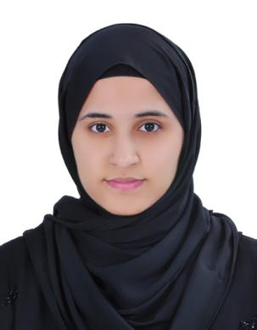Sara Ali

[Bahraini] • [960302034] • [34515065] • [Single] [[Alsuwaidisara96@gmail.com]](mailto:[Alsuwaidisara96@gmail.com])

[House 649 , Road 1409 , Block 1214 , Hamad Town]

**Career Objective**

I can work independently using my own initiative or as a part of a team.

**Achievements**

* Head Start Certificate with ( INJAZ Bahrain ) 2016/2017

**Education**

**2011 – 2014**  Al-Tadamun Secondary School.

**Skills**

Computer Skills:

* Microsoft Office

Interpersonal skills:

* Quick learner
* Teamwork
* Able to work under pressure

**Hobbies and interests**

Reading

Cooking

**Languages**

English

Arabic